Wendy Shaw

459 words

**Galatasaray Exhibitions**

Taking place in Istanbul between 1916 and 1951, the Galatasaray Exhibitions were the first annual exhibitions of art established in the Ottoman Empire and remained an important cultural event during the single-party era of the Republic of Turkey, founded in 1923. During the Great War in Europe, when the Ottoman Empire joined the Central Powers and the citizens of Entente nations left, many vacated spaces in Istanbul opened to new uses. One of these was the Italian Societa Operaia, which became the dormitory for the nearby Lycée de Galatasaray. Beginning in 1916, the main hall of this dormitory was leased every summer for an annual exhibit, which came to be known as the Galatasaray Exhibition. At the first exhibit, the works exhibited were naturalist paintings reflecting no awareness of contemporary modernist movements--a situation that changed later with the development of the modern national state. The exhibit was juried but open to all artists, and visitors were charged admission. Several works at the 1916 exhibit received prizes from the Ministry of Education and were subsequently purchased as part of the Collection of Decorated Panels established under the auspices of the Imperial Academy of Fine Art, which included copies of many famous European paintings.

Awards went to paintings of women by İbrahim and Feyhaman, landscapes by Hikmet, Halil, and Hüseyin Zekai, an interior of Hagia Sophia by Viçen Arslanyan, and *Collections* *for the Red Crescent* by Mehmed Ruhi. Its selection for an award probably reflected the role of the Red Crescent as a sponsor of the exhibit that gave medallions to all the organizers (İrepoğlu 1986, 55). The Galatasaray Exhibit of 1916 was also the first venue at which Muslim Ottoman artists exhibited nudes, including works by İzzet Ziya and Namık İsmail.

The war years fostered a new sense of collective identity based on the nation-state. While there were various political understandings of the nation, ranging from the formation of a national Ottoman state to the development of an ethnically-based Turkey, the notion of developing a collective voice was becoming a central concern for artists. Discussing the Galatasaray Exhibit of 1917, Nazmi Ziya explained, “Painters have until now proceeded according to their own conceptions and attitudes, and this is just the second time they are making a public appearance. It will take a little more time before they understand the spirit of the people and what they want, can develop vehicles for explaining their own emotions, or directly express the spirit of the nation. Then painting will have found a local and national path which will lead to its goal”.

**References and further readings:**

Nazmi Ziya. *Yeni Mecmua* 8 (August, 1917).

Şerifoğlu, Ömer Faruk. Resim *Tarihimizden Galatasaray Sergileri,* 1916−1951. Istanbul: Yapı Kredi Yayınları, 2003.

Shaw, Wendy M. K., *Ottoman Painting: Reflections of Western Art in the Ottoman Empire.* London: I. B. Tauris, 2011.

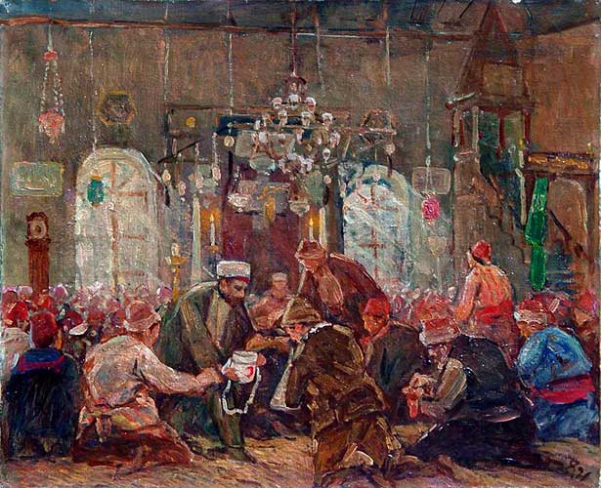

Mehmed Ruhi (Arel). *Collections for the Red Crescent*. 1916. Oil on Canvas, 38 x 46 cm. Mimar Sinan Güzel Sanatlar Üniversitesi (MSGSÜ) Istanbul Museum of Painting and Sculpture.